2024 Brain Injury Awareness Month Communication Toolkit
March is Brain Injury Awareness Month. Please feel free use this communication toolkit to raise awareness of Brain Injury Awareness Month as well as the accomplishments of the Traumatic Brain Injury Model System (TBIMS) centers, the TBIMS National Database, and the Model Systems Knowledge Translation Center’s (MSKTC) consumer resources for people living with traumatic brain injury (TBI). The toolkit offers shareable materials and links to various knowledge translation tools (KT) to help you promote awareness. Please feel free to modify the messages to suit your audience’s needs.

Social Media
Please use the sample social media messages and graphics below on your social media channels.
Please tag:
@MSKTCTBI on Facebook; @TBI_MS on Twitter; and, @TBIModelSystem on Instagram.
Note: This is suggested post language that you should tweak to fit your own writing style and channels. Social media algorithms will downrank “copy pasta,” or posts with the exact same language, so you will want to modify it slightly before posting or risk low/no engagement.

Social Media Messages
- Looking for #BrainInjury resources during March #BrainInjuryAwarenessMonth? @TBI_MS resources are free, based on research, and developed for those who need them the most. #MSKTC_TBI https://msktc.org/tbi
- @CDCInjury reports 2.9 million TBI-related #EmergencyDepartment visits, hospitalizations, and deaths per year in the US. Learn how @TBI_MS have contributed to research and care for people with #BrainInjury #BrainInjuryAwareness #MSKTC_TBI https://msktc.org/brain-injury-awareness-month
- March is #BrainInjuryAwarenessMonth! @TBI_MS centers have been advancing care and outcomes for people with #braininjury over 35 years. Find a #MSKTC_TBI center near you: https://msktc.org/tbi/model-system-centers
- March is #BrainInjuryAwarenessMonth! The @TBI_MS National Database is the world’s largest longitudinal research database for #BraIninjury. Learn more: https://www.tbindsc.org/
- If you're living with a traumatic brain injury (TBI), a caregiver, clinician, or policymaker, we need your input! Take part in our survey to let us know what info you need to better serve the #TBI community. https://bit.ly/MSKTCUserSurvey
- Model Systems Knowledge Translation Center offers resources in Spanish to help you raise awareness of traumatic brain injuries during #BrainInjuryAwarnessMonth. https://msktc.org/tbi/recursos-en-espanol
- Calling all champions for traumatic brain injury (TBI) awareness! Are you passionate about making a difference? We invite individuals living with TBI, caregivers, clinicians, and policymakers to become ambassadors for change! https://msktc.org/tbi/ambassador-program

Social Media Graphics
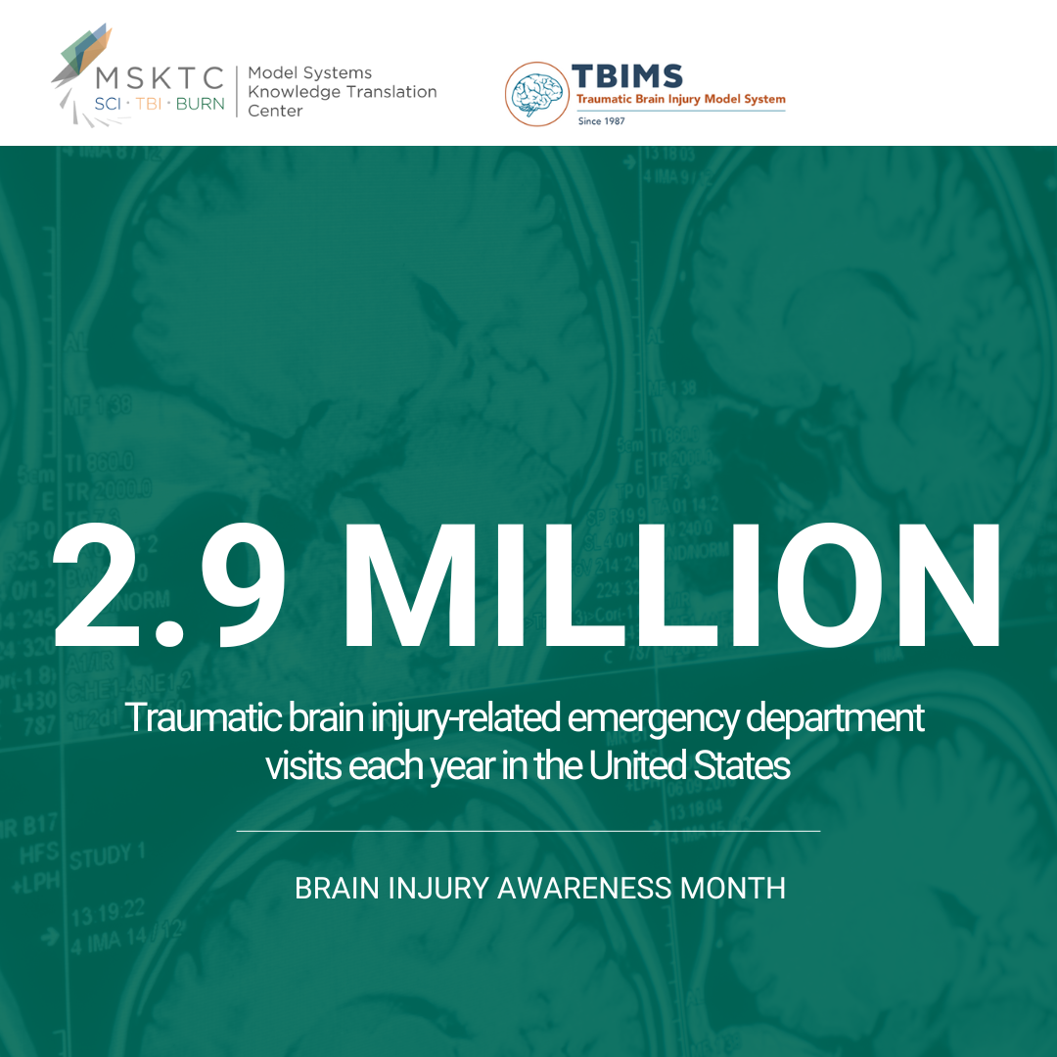 | Facebook, LinkedIn, X (Twitter):  (Download Here)  Story:  (Download Here)  Instagram:  (Download Here)

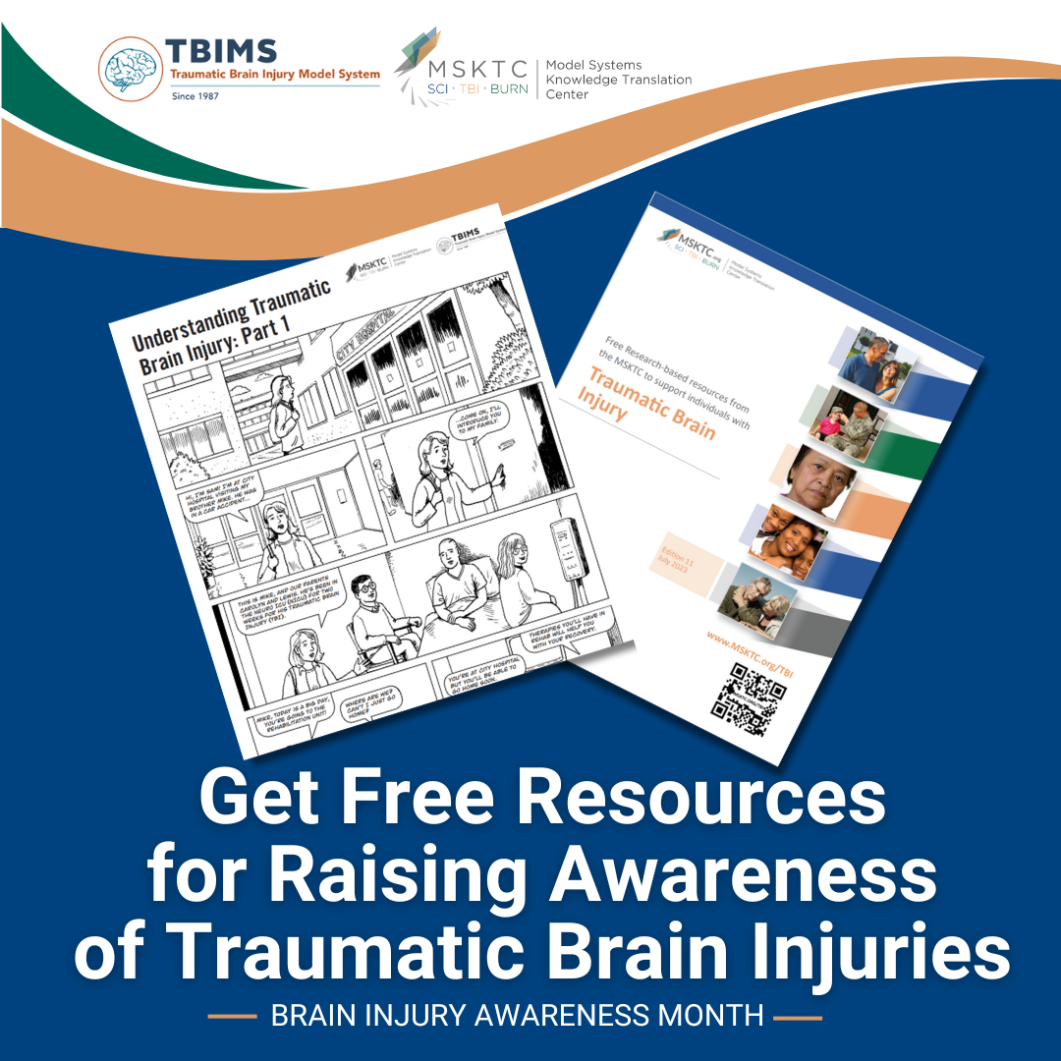 | Facebook, LinkedIn, X (Twitter):  (Download Here)  Story:  (Download Here)  Instagram:  (Download Here)

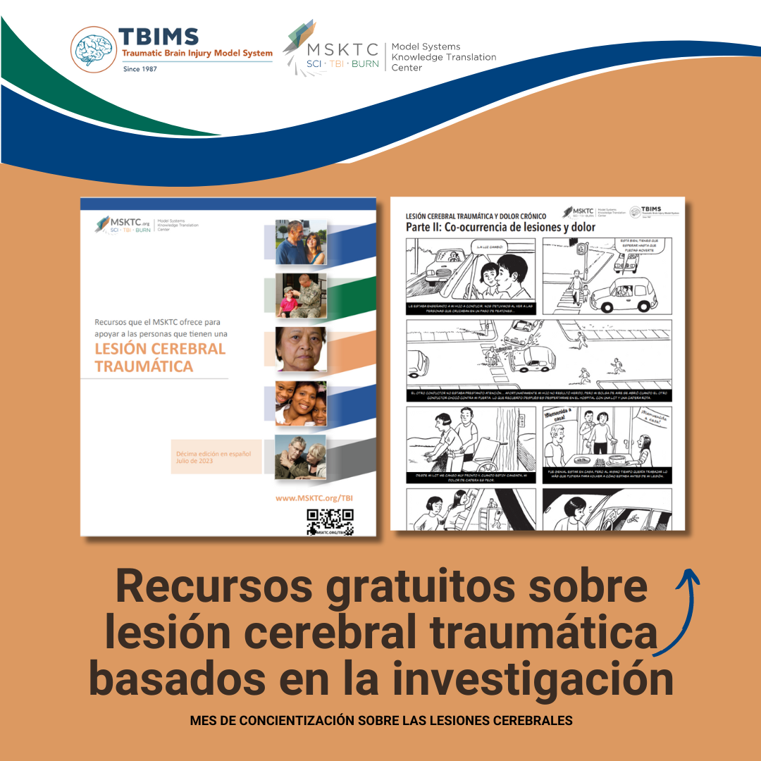 | Facebook, LinkedIn, X (Twitter):  (Download Here)  Story:  (Download Here)  Instagram:  (Download Here)

Sample Newsletter Blurb

Join the Model Systems Knowledge Translation Center (MSKTC) and the Traumatic Brain Injury Model Systems (TBIMS) in observing Brain Injury Awareness Month. Find free research-based MSKTC resources on traumatic brain injuries along with shareable materials that you can use to raise awareness in March and beyond.

Sample Email Blast
March is Brain Injury Awareness Month! The Model Systems Knowledge Translation Center (MSKTC) and the Traumatic Brain Injury Model Systems (TBIMS) are conducting a media campaign to raise awareness of brain injury as well as the accomplishments of the TBIMS centers, the TBIMS National Database, and MSKTC’s resources for people living with traumatic brain injury (TBI).
According to the Centers of Disease Control and Prevention, there are 2.9 million TBI-related emergency department visits each year in the United States. For over 35 years, TBI Model System researchers have been working to improve rehabilitation care and outcomes for people living with TBI.
- Learn more about the research and accomplishments of the TBI Model System centers here.
- Access the free research-based resources to support people living with TBI here.
- To join our campaign, please feel free to use our communication toolkit here.
Both the MSKTC and TBI Model System centers are funded by the National Institute on Disability, Independent Living, and Rehabilitation Research, Administration for Living, U.S. Department of Health and Human Services.

Additional Resources for Promoting Awareness
The MSKTC has developed knowledge translation (KT) tools to help researchers engage with the media and use social media to disseminate research findings to a wide audience. Please access our KT tools using the links below.
- Engage the Media – MSKTC Online Knowledge Translation Toolkit:
  - Developing Key Messages for Effective Communication
  - Press Release Template and Instructions
  - Responding to Media Requests
  - Working with Your Communications/Public Affairs Office
- Use Social Media – MSKTC Online Knowledge Translation Toolkit:
  - Getting Started with Social Media Advertising: Facebook & Instagram Ads
  - Guide for Developing an MSKTC Social Media Plan
  - How to Use Social Media Advertising for Research
  - MSKTC Social Media Development Workbook
  - Social Media Development Content Calendar
  - Using Social Media to Promote Research
  - Web Clinic: Social Media Analytics

The contents of toolkit were developed under grant number 90DPKT0009 from the National Institute on Disability, Independent Living, and Rehabilitation Research (NIDILRR). NIDILRR is a Center within the Administration for Community Living (ACL), Department of Health and Human Services (HHS). The contents of this toolkit do not necessarily represent the policy of NIDILRR, ACL, HHS, and you should not assume endorsement by the federal government.

