Guide for Developing an
MSKTC Social Media Plan

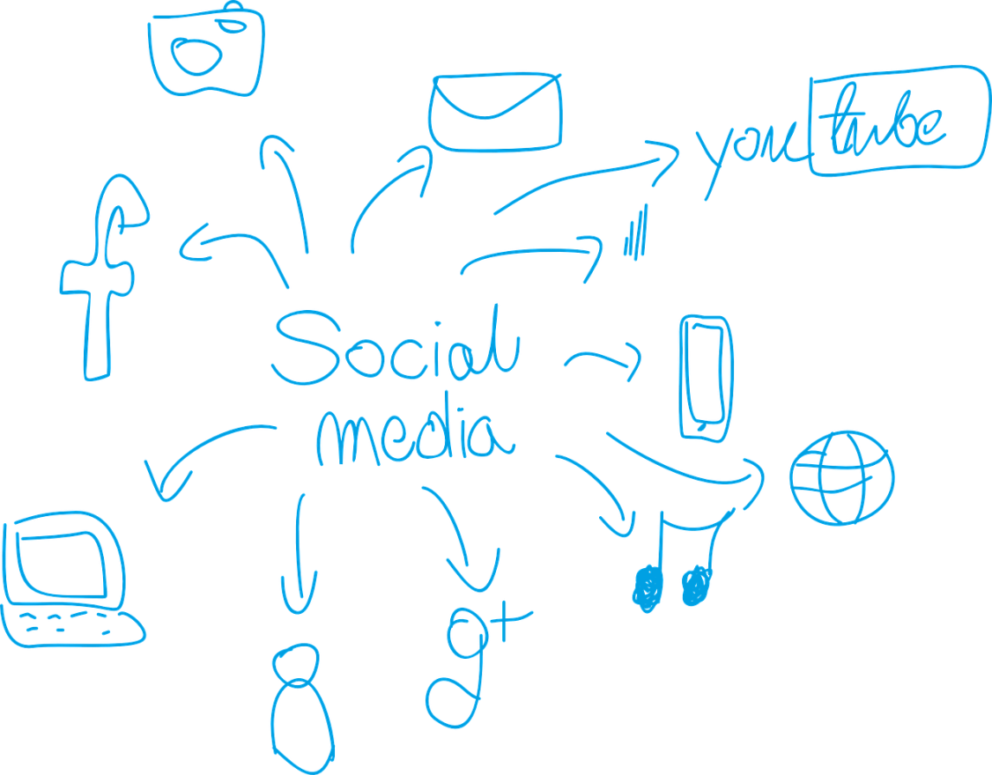

Contents
Page
Introduction 1
Stage 1: Planning 1
Planning Step 1: Set Goals 1
Planning Step 2: Allocate Resources 2
Planning Step 3: Create a Yearly Editorial Planning Timeline/Calendar 2
Planning Step 4: Identify and Create Your Ideal Audience Persona(s) 3
Planning Step 5: Select Appropriate Channel(s) 4
Planning Step 6: Define Your Voice 7
Stage 2: Executing 8
Executing Step 1: Set Up Account(s) & Profile(s) 8
Executing Step 2: Curate Content 9
Executing Step 3: Create a Monthly Content Calendar 10
Executing Step 4: Package and Post Content 12
Executing Step 5: Engage with Your Audience 13
Stage 3: Monitoring and Optimizing 15
Monitoring and Optimizing Step 1: Grow/Promote Your Social Media Channel(s) 15
Monitoring and Optimizing Step 2: Measure Results and Optimize Performance 16
References 18

Exhibits
Page
Exhibit 1. Example: Planning Timeline 3
Exhibit 2. Core Persona Characteristics 3
Exhibit 3. Example: Persona Development—Core Characteristics 4
Exhibit 4. Social Media Examples 6
Exhibit 5. Online Adults Who Use Social Media Channels 7
Exhibit 6. Example: Monthly Content Calendar 11

Introduction
The Guide for Developing an MSKTC Social Media Plan was developed to provide your Model System with practical tips, background information, best practices, and points to consider when creating a social media plan. The Guide begins with the Planning stage: how will you begin to create your social media approach and what resources do you need to accomplish it? Next, the Guide provides tools and tips for the Execution stage to make your social media work happen. The Guide concludes with the Monitoring and Optimization stage, in which you will sustain your social media approach by tracking outcomes and considering how to expand and grow your outreach efforts. This Guide is intended for use as you complete the MSKTC Social Media Development Workbook.

Stage 1: Planning
In the Planning stage, you begin with an idea—to reach audiences through social media to communicate about your research and products. In this section, you will set goals for your social media approach, identify and allocate resources, create a timeline or similar tool to plan your activities, identify and create your audience persona, select the appropriate social media channel to match your goals and audience, and define your organization’s voice. If you already have a social media approach in place, use this section to review and update your plan.

Planning Step 1: Set Goals
Aligns with Workbook pages 2-4
- Assess your Model System’s mission and determine how your social media activities will align with and support that mission.
- Examine your Model System’s policies regarding privacy, disclaimers, accessibility, and terms of use, and adopt policies for your social media activities as needed.
- Identify where your social media messages will originate from within the organization’s structure (i.e., who are you representing, the overall organization or a specific group within it?).
- Define what you want to accomplish by using social media and in what timeframe(s) you want to make those achievements. Examples of accomplishments include

- Resources downloaded
- Event registrations received
- Donations procured
- Funds raised
- Partners acquired
- Study participants recruited

Best Practice: Use the SMART model to develop your goals.
  - Specific: Define explicit goals relative to the desired results.
  - Measurable: Establish concrete criteria for gauging progress toward goal attainment.
  - Attainable: Consider potential resource restraints that may hinder goal achievement (see Planning Step 2).
  - Relevant: Ensure goals are worthwhile to the mission of your Model System.
  - Time-Based: Set the goals’ timeframe(s) to make them real and tangible.

Planning Step 2: Allocate Resources
Aligns with Workbook pages 5-7
You will need to return to this step after reviewing subsequent sections of this Guide. The amount of staff time needed will depend on which social media outlet you use, how frequently you plan to post new information, and the level of effort you intend to commit to engaging with your audiences. Bookmark this step and return to it as you work through the Guide.
- Evaluate the time, staff, technology, budget, and other resources you already have to invest in social media.
- Determine the additional time, staff, technology, budget, and other resources you will need to set up, execute, and monitor your social media activities.
Best Practice: Pay attention to the following considerations to identify the processes and procedures you will use to manage your social media activities, including
- Timelines for creating and sharing content
- Standards and style guides for content (e.g., American Psychological Association, Associated Press, Business, Chicago, custom)
- Workflows for reviewing and approving content

Planning Step 3: Create a Yearly Editorial Planning Timeline/Calendar
Aligns with Workbook pages 8-9
- Brainstorm overall concept(s)/theme(s) for social media activities that reinforce(s) your Model System’s mission on a monthly, quarterly, or yearly basis.
- Develop individual campaigns (i.e., groups of messages that work in an organized way toward a particular goal) throughout the year that align with your Model System’s activities and major milestones.
- Create an editorial planning timeline/calendar to outline all dates that are pertinent to your Model System (e.g., events, studies, fund-raising, observances, and holidays). See Exhibit 1 below.
- Acquire the appropriate buy-in from Model System staff and authorization from your organization as needed for the concept(s) and campaigns.
Exhibit 1. Example: Planning Timeline
 | JAN | FEB | MAR | APR | MAY | JUN
Campaigns |  | The Challenge! |  |  |  | Heads Up Concussion
Events |  |  | 3/12–3/14 BIAOR  Conference | 4/15–4/16 TBI Conference  4/21–4/24 ABA Meeting  4/30–5/1 NARRTC Conference | Volunteer Drive | 6/11–6/18 Art in Motion  6/20 S FL Conference SCI & TBI
Studies |  | February Study |  | April Study |  | June Study
Fund-raising |  | 3rd Party Fund-raiser | Matching Gifts Drive | 3rd Party Fund-raiser | Stock Gifts Drive | Tribute Gifts Drive
Observances |  |  | 3/18 TBI Awareness
Holidays | MLK | Valentine’s | St. Patrick’s |  |  | Beginning of Summer
Other | Sports & Rec Program | Sports & Rec Program | Sports & Rec Program | Sports & Rec Program | Sports & Rec Program | Sports & Rec Program

Planning Step 4: Identify and Create Your Ideal Audience Persona(s)
Exhibit 2. Core Persona Characteristics
- Roles (who are they?)—researchers; persons with a specific injury (name their specific injury types as applicable); policy makers, advocates, disability organizations; clinicians, physicians, providers, staff; donors, funders; media outlets, reporters; community leaders; educators; collaborators; grantees; the general public
- Interests and motivations (why should they care/what are their primary needs?)—informing the field; receiving help for injuries; changing policy, passing legislation; preventing injury; treating injury; raising funds; donating funds; caring for patients; partnering, collaborating; educating others; reporting news or events
- Online behaviors (how do they communicate?)—type of social media they use; how they use social media; how they obtain information; how they prefer to engage online with organizations like yours; what other organizations are they affiliated with through social media
Aligns with Workbook pages 10-14
Personas are fictional characters created to represent each type of person who might use your Model System’s social media. By creating personas, you and your staff will have a sense of the general audience type(s) that you are trying to reach.
- Analyze your current audience(s), identifying their core persona characteristics as well as how your Model System serves them, barriers to serving them, how they interact and engage with your Model System, and their feedback of your Model System (positive and negative). From your current Model System audience, who uses social media and why?
- Create personas of your ideal social media audience(s), defining their core persona characteristics as well as ideal ways in which your Model System will address their interests and motivations through social media, communicating in their preferred manner.
Exhibit 3. Example: Persona Development
PERSONA EXAMPLE
Role | Researcher
Interests and Motivations | His current research interests include the role of neurotransmitter signaling during early stages of nervous system development; the signals that influence the proliferation, migration, and differentiation of cells of the cerebral cortex; and stem cell biology. When he’s not working, he enjoys playing disc golf and enjoying quality time with his four grandchildren.
Online Behaviors | - Uses LinkedIn for professional networking. After each conference he attends, he takes the business cards of the other experts he met and finds and connects with them on this channel.  - Uses Facebook to keep in touch with friends from college and grad school as well as to see pictures of his grandchildren. He also “likes” pages of organizations that provide information and resources on neurobiology, stroke, and traumatic brain injury.  - Uses Twitter to stay up-to-date on current events, including new research and conference opportunities in his profession.
Best Practice: Pay attention to the following considerations when developing your audience personas:
- Compliance and accessibility: Individuals with visual, auditory, physical, speech, cognitive, and neurological disabilities may have trouble accessing, understanding, and using your social media unless you apply Section 508 compliance and accessibility standards.
- New versus returning visitors: First time visitors to your social media may have different needs than returning or repeat visitors.
- Change happens: Audiences change. Needs change. Technologies change. Provide ongoing opportunities to learn from your visitors and update your personas on a regular basis to be certain that you are reaching the audiences you intend to reach.

Planning Step 5: Select Appropriate Channel(s)
Aligns with Workbook pages 15-16
- Adopt one to two, best-fitting channel(s) first, and build on successes by adopting additional tools as needed over time. Hint: It is more important to be great at one channel than mediocre at three or four channels.
There are a growing number of social media channels to choose from. Following are the current top five social media channels, some information about their popularity, challenges to using these channels, and how they may already be used by your Model System’s audiences. Consider these channels and determine which channels are the best fit for your goals, resources, and audience:
- Facebook—Provides the best social media “bang for your buck”
  - Is used by 71% of all adult Internet users
  - Remains the most popular site for those who only use one channel (79%) and has significant overlap with other platforms
  - Engagement continues to grow, while daily use of most other channels showed little change between 2013 and 2014
  - Usage among seniors continues to increase
  - Has now become an alternative to visiting a stand-alone website
  - Can be used to post text-only updates, links to content on websites, images, and videos
  - Users share 1 million posts with their networks every 20 minutes
  - Comes with drawbacks like a low organic reach for organizations (relies on “pay-to-play”/advertising model) and an increasing saturation of pages vying for users’ attention
- Instagram—
  - Is used by 26% of all adult Internet users
  - Saw a significant increase in the proportion of users among most demographic groups between 2013 and 2014
  - Is likely to be used by young adults, women, Hispanics and African Americans, and those who live in urban or suburban environments
  - Can be used to post images, (15-second) videos
  - Comes with drawbacks like a lack of in-post linking capability, a lack of in-site analytics and scheduling features, and an advertising platform still in its infancy
- Twitter—
  - Is used by 23% of all adult Internet users
  - Has seen significant increases among a number of demographic groups: men, Whites, those aged 65 and older, those who live in households with an annual household income of $50,000 or more, college graduates, and urbanites
  - Can be helpful in engaging with consumers and relaying information quickly
  - Can be used to post text-only updates, links to content websites, images, and videos
  - Comes with drawbacks like limiting each post to 140 characters, an expensive and limited advertising platform, short lifespan of posts due to the high volume of content being shown to users
- Pinterest—
  - Is used by 28% of all adult Internet users
  - Experienced an 11-point increase between 2013 and 2014 in the proportion of those aged 50 and older who use the channel
  - Saw a notable increase in usership among Whites, those living in the lowest- and highest-income households, those with at least some college experience, and suburban and rural residents
  - Can be used to post images and videos with links to content websites
  - Comes with drawbacks like a lack of effectiveness for organizations with a limited web presence and shortage of high-quality and interesting images
- LinkedIn—
  - Is used by 28% of all adult Internet users
  - Continues to be particularly popular among college graduates, those in higher-income households, and the employed
  - Is the only channel where those aged 30–64 are more likely to be users than those aged 18–29
  - Can be used to post text-only updates, links to content websites, original content (through its Publisher platform)
  - Comes with drawbacks like a limited reach outside of business-to-business
Exhibit 4. Social Media Examples
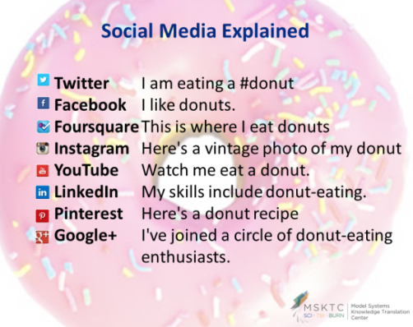
Keep the following chart as a fun way to remember how different social media channels have different purposes, reach different audiences, and use different syntax in their messaging. Think about what you want to share via social media and consider the following chart, which explains eight different ways to tell social media audiences about that donut you are enjoying:
Also consider this in-depth usage data for key social media channels. Exhibit 5 lists the percent of online adults in the United States who used each channel in 2014.
- Compare the personas you developed in Planning Step 4 to the information provided above to determine which social media channels fit best with each audience you want to reach.
Exhibit 5. Online Adults Who Use Social Media Channels
 | BY  GENDER | BY RACE/ ETHNICITY | BY  AGE | BY  EDUCATION | BY  FREQUENCY
Facebook | 66% Men  77% Women | 71% White  67% Black  73% Hispanic | 87% 18–29  73% 30–49  63% 50–64  56% 65+ | 70% High school grad or less  71% Some college  74% College+ | 70% Daily  (45% 2+ x/Day)  17% Weekly  12% Less Often
Instagram | 22% Men  29% Women | 21% White  38% Black  34% Hispanic | 53% 18–29  25% 30–49  11% 50–64  6% 65+ | 23% High school grad or less  31% Some college  24% College+ | 49% Daily  (32% 2+ x/Day)  24% Weekly  26% Less Often
Twitter | 24% Men  21% Women | 21% White  27% Black  25% Hispanic | 37% 18–29  25% 30–49  12% 50–64  10% 65+ | 16% High school grad or less  24% Some college  30% College+ | 36% Daily  (22% 2+ x/Day)  24% Weekly  40% Less Often
Pinterest | 13% Men  42% Women | 32% White  12% Black  21% Hispanic | 34% 18–29  28% 30–49  27% 50–64  17% 65+ | 22% High school grad or less  30% Some college  32% College+ | 17% Daily  (9% 2+ x/Day)  29% Weekly  52% Less Often
LinkedIn | 28% Men  27% Women | 29% White  28% Black  18% Hispanic | 23% 18–29  31% 30–49  30% 50–64  21% 65+ | 12% High school grad or less  22% Some college  50% College+ | 13% Daily  (7% 2+ x/Day)  25% Weekly  61% Less Often
NOTE: Multi-channel use is increasing, with 52% of online adults now using two or more social media sites, a significant increase from 2013, when it stood at 42% of Internet users.

Planning Step 6: Define Your Voice
Aligns with Workbook pages 17-18
Your “voice” is your organization’s personality. Social media provides the opportunity to humanize organizations and make them relatable to their audience.
- Reflect on the voice your Model System currently uses in various media (e.g., website, e-newsletters, brochures, letters).
- Use the following categories and related attributes to define the voice you will use in your Model System’s social media channel(s):
- Character—Attributes include: friendly, warm, inspiring, relaxed, authoritative, professional
- Tone—Attributes include: personal, humble, clinical, honest, direct, scientific
- Language—Attributes include: complex, savvy, insider, serious, simple, jargon-filled
- Purpose—Attributes include: engage, educate, inform, enable, convince, amplify
- Although you may adopt slightly different voices depending on the channel, you should aim for consistency across all social media properties.
- If multiple people are working on social media activities, review the voice you want to project with staff to ensure consistency.
- Refer back to your goals and editorial planning timeline/calendar when questions arise.

Stage 2: Executing
In the Execution stage, you will put your plans to work. First, set up your social media account and profile, then determine the process for adding content. You will need to create a calendar—a sample monthly calendar is included with this Guide—then determine how to package and begin posting content. In addition, you will begin to engage with your audiences and build your relationships and networks.

Executing Step 1: Set Up Account(s) & Profile(s)
Aligns with Workbook pages 19-24
- Set up your social media account(s) with a common, organizational e-mail address/login, rather than using a staff member’s personal e-mail address. This is especially important when multiple staff members will be accessing and managing the account(s).
- Create account(s) for the top 1–2 channels you chose in Planning Step 5, following the guidelines provided by the channel(s). Hint: Remember that the process for creating a social media account and setting up a profile will vary by channel and can change from time to time, so you will need to examine the platform you will use to determine what elements are required at the time of set-up.
- Consider setting up peripheral accounts to help you manage your account(s), schedule posts, review analytics reports, and shorten URLs. The two most-recommended tools are
- Hootsuite—a social media management system for brand management using a dashboard user interface to support social media integrations and analytics for Twitter, Facebook, LinkedIn, Instagram, and others
- bitly—a URL shortening service that can be used with any social media channel and helps users fit web addresses into character limits and track clicks on links
- Determine the name and/or username, biography and/or description, contact information, logos, branding images, website link(s), administrator roles, and privacy settings you will use for each account. Demonstrate a consistent brand experience across all online properties, including your website and social media channels.
- Find 25–50 accounts to follow on a regular basis on each channel you chose to use.
- After the first 4 weeks, aim to keep your following ratio (i.e., the number of accounts you follow compared to the number of accounts that follow you) between 10:100 and 100:100.
- Follow accounts of those you want to follow you in return. Hint: Review those accounts’ followers and who they’re following in turn to find additional relevant accounts to follow.
- Follow the known “experts” in your field.
- Follow news sources relevant to your topic area or research area.
- Use the search tool in the social media channel(s) you chose to find accounts that are posting about your field.
  - Search a variety of relevant terms, phrases, and hashtags (see Executing Step 2).
  - Follow the accounts that are contributing most to the conversation.
- As your audience grows (see tips for increasing your follower count in Monitoring & Optimizing Step 2), continually analyze followers, follow back appropriate accounts, and follow relevant accounts that your audiences follows.

Executing Step 2: Curate Content
Aligns with Workbook pages 24-25
- Identify original, internal content.
- Analyze your current content assets, including information on your website, calendars (e.g., special events, fund-raising drives, in-house education programs, opportunities for involvement and volunteering, employee events), e-newsletter(s), etc.
- Use those assets to package your social media (which you can publish in Executing Step 4), aligning all online properties in a coordinated approach to information dissemination.
- Find relevant and useful content from others (external content).
- Set a schedule (e.g., 2–3 times per month, 1–2 times per week) to search other sources for content to share.
- Examples include websites, e-newsletters, and social media accounts from
  - Other Model Systems
  - Relevant experts/leaders in the field
  - Federal resources
  - News/media outlets
- Consider these content examples when searching for material to use:

- Information:
  - Scope of work
  - Patient education/consumer factsheets
  - Interviews
  - Seasonal/holiday tips
- Research/clinical studies:
  - Findings
  - Participant recruitment
- Research:
  - Publications
  - Scientists’ activities
- Announcements/press releases:
  - Funding/grant opportunities
  - Partner achievements
- Events:
  - Conferences
  - Fund-raising
  - Webinars
  - Trainings
  - Lectures
  - Discussion/focus groups
- Calls-to-Action/Participation:
  - Asking followers questions
  - Communicating with partners
- Ads:
  - Recruitment efforts
  - Funding drives
  - Major news

- Employ the power of hashtags. Note: The pound sign—or hash—turns any word or group of words that directly follow it into a searchable link. This allows you to organize content and track discussion topics based on those keywords. The use of hashtags is supported in Facebook, Instagram, Twitter, and Pinterest. LinkedIn does not currently support hashtags; however, they recently enabled the ability to add three keyword tags to posts, which functions in a similar way.
- Search for existing hashtags that are relevant to your Model System and join the conversation and attract viewers interested in content like yours.
- Create new hashtags to promote your Model System’s activities.

Executing Step 3: Create a Monthly Content Calendar
Aligns with Workbook pages 26-27
Use the sample spreadsheet from the MSKTC to complete this Step. See Exhibit 6.
- Using the timeline you created in Planning Step 3, analyze this month’s major milestones (e.g., observances, holidays, events, studies, fund-raisers, campaigns, resource launches).
- Align this month’s major milestones with the goals you set in Planning Step 1 and the content you curated in Executing Step 2.
- Decide which content can be used across all social media channels and which will be channel-specific.
- Select when the campaigns will need to be executed. Leave room for real-time, ad hoc updates, as needed.
- Determine the frequency of developing and reviewing content (e.g., 1 time per month, 1 time per week).
- Determine the frequency of packaging and posting content (e.g., 2 times per day, 3 times per week). Use a scheduling tool to queue a batch of posts ahead of time.
Best Practice: Consider the following recommended posting frequencies by channel:
- Facebook: Up to 2 times per day
- Instagram: Up to 2 times per day
- Twitter: At least 5 times per day; up to 20 times per day
- Pinterest: Up to 2 times per day
- LinkedIn: Up to 1 time per day
- Revisit Planning Step 2 and consider the resources you have allocated to execute your social media plan to ensure that you have the right level of effort to contribute to this work.
Exhibit 6. Example: Monthly Content Calendar
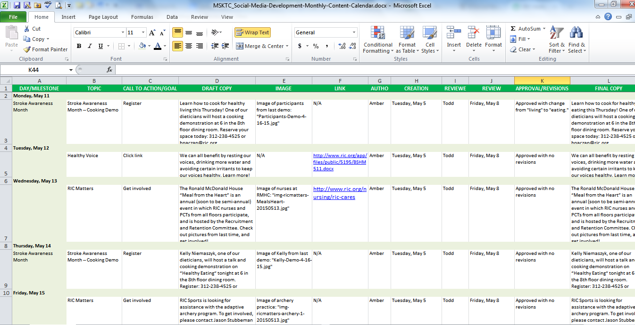

Executing Step 4: Package and Post Content
Aligns with Workbook pages 28-29
- Now that you have found the material you will use in your social media activities and established when that content will be developed and published, you will need to decide the format you will use to disseminate that content.
- Start with the basic post formats, including text-only updates, links to content on websites, images, and videos. Remember that the type of content you develop will depend on the channel(s) you chose in Planning Step 5:
  - Facebook—text-only updates, links to content on websites, images, videos
  - Instagram—images, (15-second) videos
  - Twitter—text-only updates, links to content on websites, images, videos
  - Pinterest—images and videos with links to content on websites
  - LinkedIn—text-only updates, links to content on websites, original content (through its Publisher platform)
- Choose a “staple” post, a single format to constitute the majority of your social media posts.
- Create a 4:1 ratio of posting: for every four “staple” updates you post, publish one different format for variety.
- Put together the content you curated. Then, using the chosen format, write the text and add the images, videos, and/or links to content on websites that you will share on your social media channel(s). Hint: Provide the same content in multiple formats to increase accessibility, reinforce messages, and give your audience different ways to interact with your channel(s) based on their level of engagement and access to media.
- Include a call-to-action in every post, using a strong verb to direct your audience to complete the action you desire. Examples include

- “View...”
- “Download…”
- “Register...”
- “Sign up…”
- “Connect...”
- “Join…”
- “Visit...”
- “Donate…”
- “Partner…”
- “Read…”
- “Share…”
- “Participate…”
- “Volunteer…”
- “Learn…”
- “Comment…”
- “Watch…”
- “Reserve…”
- “Give…”

- Publish the content you developed to your chosen social media channel(s), using scheduling tools to queue batches of posts ahead of publishing time.
Best Practice: Read the Centers for Disease Control and Prevention’s (CDC’s) Guide to Writing for Social Media, and consult The CDC Clear Communication Index, a research-based tool to help develop and assess public communication materials. The Index supports CDC’s efforts to
- Comply with the Plain Writing Act of 2010 and expanded plain language techniques described in the Federal Plain Language Guidelines.
- Achieve goals set forth in the National Action Plan to Improve Health Literacy.
- Achieve goals set forth in the CDC Action Plan to Improve Health Literacy.

Executing Step 5: Engage with Your Audience
Aligns with Workbook pages 30-32
When developing content, it is important to engage your audience in discussion, both with your Model System and with each other.
Creating Opportunities for Engagement
- Use questions, surveys, quizzes, and polls.
- “Listen” to your audience’s responses.
- Respond within 1 hour and no later than 24 hours, as appropriate, to build relationships and show the “human” side of your Model System’s organization.
- Report back to your audience on any quiz or poll results.
- If unexpected, insightful, or on-trend topics arise, use those ideas to spur further conversations.
- Cultivate and share audience testimonials and success stories.
- Use the existing Patient Stories and videos from your website.
- Ask your audience to share new stories about their experiences with your Model System.
Responding to Your Audience
- Check your account(s) and respond to audience comments at least daily to build alliances and stay on top of conversations. Hint: Engagement is more than just quickly responding to comments/questions directed at you, and audiences can quickly tell if you are only interested in/equipped to handle one-way communication.
- Determine how you will handle challenging questions or comments. Think through the implications of responding (or not responding) and decide whether offering a response is appropriate, considering these questions:
  - Would your response stay within the mission of your Model System?
  - Is it a baiting question, meant to be divisive and controversial?
  - Would responding create an unsustainable expectation for responding to other inquiries?
  - Is there someone else better apt to address the question or comment?
  - Is the question coming from a reporter or prominent blogger?
  - How likely will you responding garner media attention?
- When you respond, consider using one of the following methods. Generic, boilerplate responses have their purposes, but often miss the point of direct engagement.
  - Respond directly to the original comment. For instance, if a question was posted on your Facebook page, you may choose to post a response as a comment or reply to the original post. Be aware that this may set an unsustainable expectation with your audience if you do not have adequate time and staff resources for this method.
  - Respond with a subsequent post. Instead of directly responding to a single individual, you may choose to provide the information to all followers. This indirect communication can help avoid setting expectations of direct responses to all individuals.
  - Point to existing content or add new information/resources on your website. If a question or comment requires a more extended response than is allowable on certain social media channels, you may choose to use your primary web communication platform (e.g., website, blog) and then direct the original commenter to this resource in your response.
- Give time for others to respond to the question/comment raised. Do not monopolize the conversation.
- Remove inappropriate comments, and when needed block problematic audience members.

Stage 3: Monitoring and Optimizing
In the Monitoring and Optimizing stage, after you have executed your plan for social media, you will want to make sure you have optimized your approach and built an ongoing effort to reach audiences. Also, it is important to track your social media outreach and use data to inform both ongoing work and future changes to your plan.

Monitoring and Optimizing Step 1: Grow/Promote Your Social Media Channel(s)
Aligns with Workbook pages 33-34
- Identify and learn about potential partners, allies, and “cheerleaders.”
- Identify organizations similar to your Model System (e.g. other Model Systems, local businesses, national organizations, government agencies) with which you can partner to cross-post/promote each other’s social media content.
- Find organizations and individuals (e.g., new physician residents, staff members, Consumer Advisory Board members) to join your audience, become allies, and support your social media activities.
- Leverage the help of relevant influencers to be your cheerleaders by asking them to share your content, highlight your account(s), and use relevant hashtags.
- Promote your social media channel(s) throughout your Model System’s other activities.
- Include your social media channel(s) in all marketing materials—online and offline.
- Advertise your social media channel(s) during outreach efforts.
- Add a social sharing button or box to your website.
- Include your social media channel(s) information in guest author bios.
- Provide a link to your social media channel(s) in your staff’s e-mail signatures.
- Cross-promote your social media channel(s) on your other social media accounts, as applicable.

Monitoring and Optimizing Step 2: Measure Results and Optimize Performance
Aligns with Workbook pages 35-36
- Consider the following categories of social media measurement to report usage, monitor trends, and gauge the success of specific promotions or outreach efforts. This is not an exhaustive list of measures, and note that the terminology changes from channel to channel.
- Exposure (the reach of your channel(s) to your audience(s) and others)—This includes visits, views, impressions, followers, fans, and subscribers.
- Influence (the power of your channel(s) among other accounts)—This includes share of voice, sentiment, and top influencers.
- Engagement (the interaction of your audience(s) with your channel(s))—This includes clicks, reposts, shares, replies, messages, mentions, posts, comments, and shares.
- “Conversion” (a marketing term that refers to your audience(s) accomplishing the goal/taking the action you intended from using your channel(s))—This includes content downloads, event attendance, funds raised, partners acquired, and study participants recruited. Consider these additional measures of conversion (or outcomes):
  - Use of the information you provide
  - Health impact/behavior change
  - Understanding of current issues, knowledge levels, and potential misunderstandings or myths about your health topic
- Develop a procedure and schedule to review your metrics on a regular basis (e.g., complete a metrics reporting dashboard during the first week of every month for the prior month). Hint: You may also use the reporting tools inherent to the channel(s) you chose to gain regular insight into the health of your overall account(s) and individual posts (e.g., Facebook Insights, Twitter Analytics, Bitly Analytics, Hootsuite Analytics).
- Use the metrics to revise your approach, building on what is working and discontinuing what is not working.
- After you develop a baseline of how your chosen channel(s) perform, test different elements to determine if changes garner a lift in results. Testing topics can include, but are not limited to
- Time of day content is posted
- Day of the week content is posted
- Timing of posts relative to the timing of the event/campaign/etc. about which it is developed
- Format of content
- Calls-to-action used
- Links used
- Images and videos used
- Channel used; it may be worth starting the Workbook again to branch out to a new channel.

References

ABOUT AMERICAN INSTITUTES FOR RESEARCH
Established in 1946, with headquarters in Washington, D.C., American Institutes for Research (AIR) is an independent, nonpartisan, not-for-profit organization that conducts behavioral and social science research and delivers technical assistance both domestically and internationally. As one of the largest behavioral and social science research organizations in the world, AIR is committed to empowering communities and institutions with innovative solutions to the most critical challenges in education, health, workforce, and international development.
LOCATIONS
Domestic
Washington, D.C.
Atlanta, GA
Austin, TX
Baltimore, MD
Cayce, SC
Chapel Hill, NC
Chicago, IL
Columbus, OH
Frederick, MD
Honolulu, HI
Indianapolis, IN
Metairie, LA
Naperville, IL
New York, NY
Rockville, MD
Sacramento, CA
San Mateo, CA
Waltham, MA
International
Egypt
Honduras
Ivory Coast
Kyrgyzstan
Liberia
Tajikistan
Zambia

1000 Thomas Jefferson Street NW
Washington, DC 20007-3835
202.403.5000
www.air.org

Adapted from Doran, G. T. (1981). There's a S.M.A.R.T. way to write management's goals and objectives. Management Review, 70(11) (AMA FORUM), 35–36.
All data from Pew Research Center. (2015). Social Media Update 2014.
Mashable. (2013). The Beginner's Guide to the Hashtag.
Adapted from HHS Guidance on When and How to Engage over New Media Platforms (PDF, 3 pages).

