KT for OT Course
Sample Social Media Messages and Graphics

Introduction
This document contains sample social media messages and graphics to promote a new knowledge translation (KT) course: KT Course for OTs: Supporting Evidence-Based Practices. This online course introduces the basic concepts of knowledge translation as it relates to the practice of occupational therapy (OT). It presents various definitions of KT, introduces a model for KT research and application activities, and helps clarify the role of OTs in the KT process.

Please share these messages to let your networks know about the free, self-paced online KT Course for OTs: Supporting Evidence-Based Practices. Find flyers to promote this new course here.

General Message
- This free, online course from #MSKTC introduces the basic concepts of #knowledgetranslation as it relates to the practice of #occupationaltherapy. It is designed for OT students, instructors, and #occupationaltherapists. https://msktc.org/kt-for-ot

Messages and Graphic for OT Students
- Learn how #knowledgetranslation (KT) can help #occupationaltherapy (OT) #students learn and implement evidence-based practices that lead to improved patient outcomes. Access the free course here: https://msktc.org/kt-for-ot
- The Model System Knowledge Translation Center (#MSKTC) developed a new, free #knowledgetranslation course for #occupationaltherapy #students! Access KT for OT here: https://msktc.org/kt-for-ot
- Check out this new, free #knowledgetranslation course for #occupationaltherapy students developed by the Model System Knowledge Translation Center (#MSKTC). Access it here: https://msktc.org/kt-for-ot

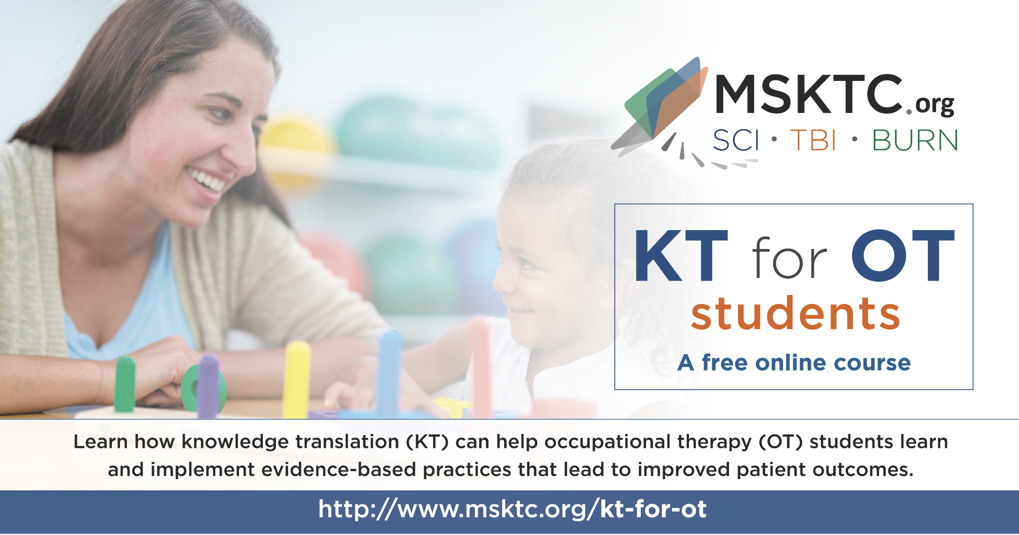

Messages and Graphic for OT Professionals
- The Model System Knowledge Translation Center (#MSKTC) has developed a new, free #knowledgetranslation course for #occupationaltherapists! Access the online course here: https://msktc.org/kt-for-ot
- Check out the new, free #knowledgetranslation course for #occupationaltherapists developed by the Model System Knowledge Translation Center (#MSKTC). Access it here: https://msktc.org/kt-for-ot
- Learn how #knowledgetranslation (KT) can help occupational therapists (OTs) implement evidence-based practices that lead to improved patient outcomes. New, free online course available here: https://msktc.org/kt-for-ot
- This new, free course from #MSKTC presents various definitions of #knowledgetranslation (KT), introduces a model for KT research and application activities, and helps clarify the role of occupational therapists in the KT process. Access it here: https://msktc.org/kt-for-ot

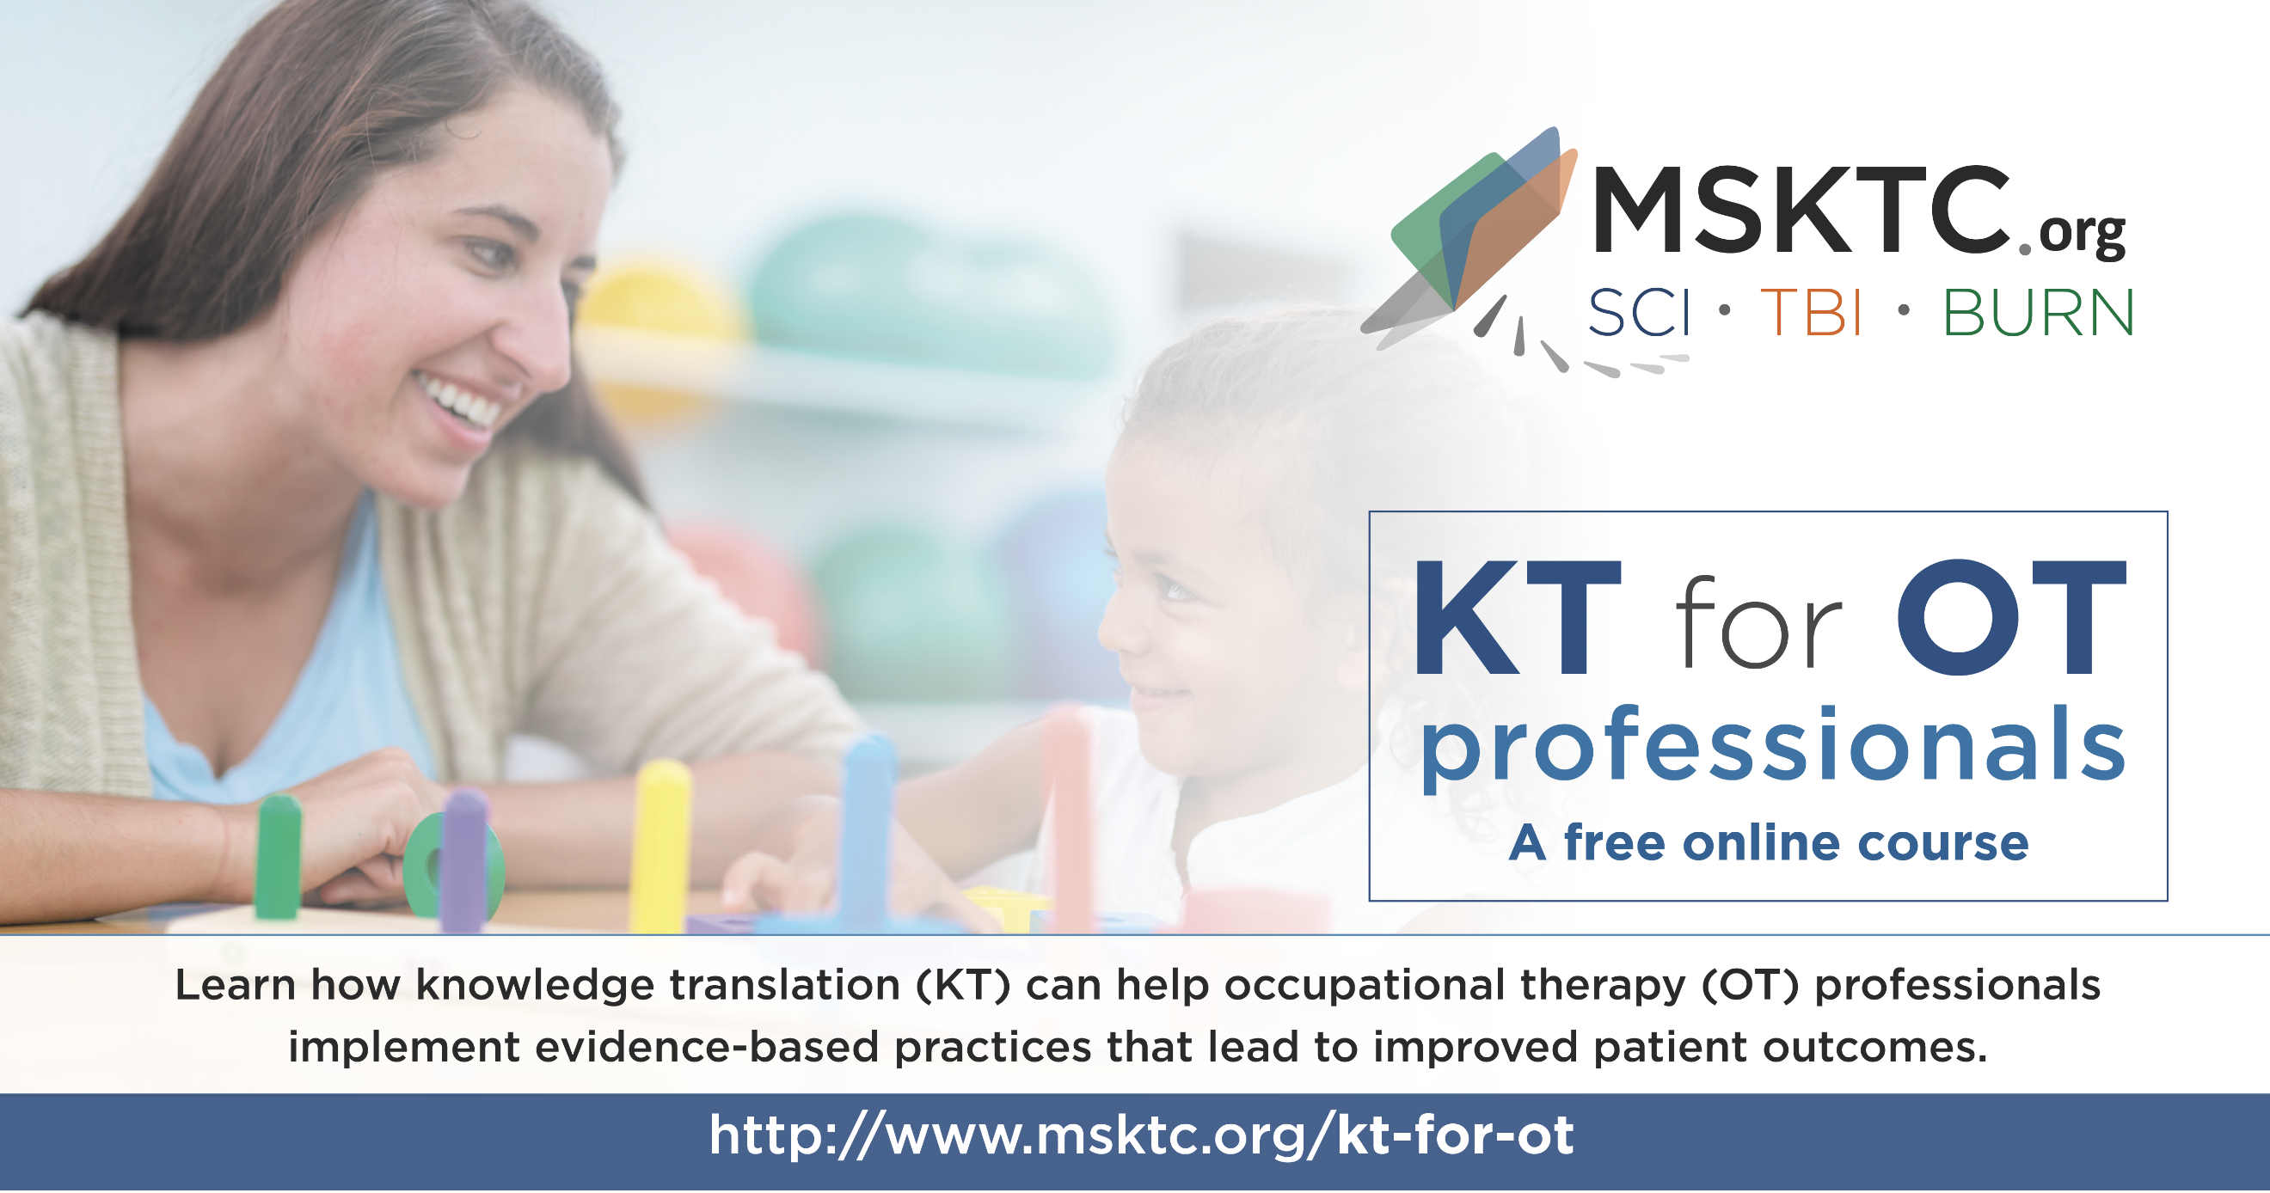

Messages and Graphic for OT Instructors
- The #MSKTC has developed a new, free #knowledgetranslation course for #occupationaltherapists! The course includes an instructor guide to support #OT instructors who assign the online course to students. Access the online course here: https://msktc.org/kt-for-ot
- Check out the new, free #knowledgetranslation course for #occupationaltherapists developed by the #MSKTC. The course includes an instructor guide to support #OT instructors who assign the online course to students. Access the online course here: https://msktc.org/kt-for-ot
- Attention #OT #instructors! The #MSKTC has developed a new, free #knowledgetranslation (KT) course for OTs! The course includes an instructor guide to support OT instructors who assign the online course to students. Access the online course here: https://msktc.org/kt-for-ot
