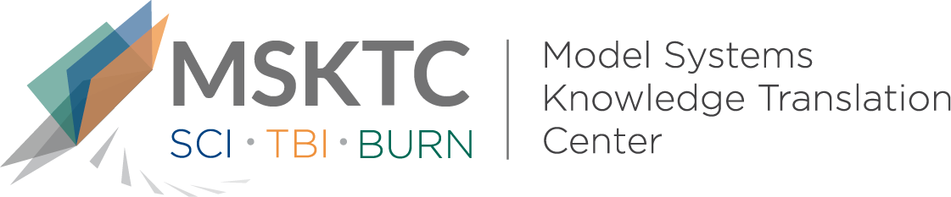

Quick Review of
Model System Research

Measuring Fatigue in TBI: Development of the TBI-QOL Fatigue Item Bank and Short Form

What is the study about?

The aim of this is study was to develop a specific evaluation tool to assess patient reported experience and impact of fatigue on people with traumatic brain injury (TBI). This was part of the larger Traumatic Brain Injury-Quality of Life (TBIQOL) measurement system. A computer adpative test was developed to test the reliability of the TBI-QOL Fatigue.

What did the study find?

The study found that the TBI-QOL Fatigue is both relaible and appropriate for measursing self-reported fatigue in indviduals with TBI. It offers high quality test information across a broad range of symptom severity.

Who particpated in the study?
Participants were 590 adults with mild, moderate, and severe TBI.

How was the study conducted?
The study conducted phone/in-person interviews and focus groups with individuals with TBI, caregivers, and TBI clinicians to develop ratings for the items to be included in the TBI-QOL Fatigue. Fatigue items were taken from the Patient-Reported Outcomes Measurement Information System (86 items) and the Quality of Life in Neurological Disorders system (9 items). After several different types of analysis, some items were omitted due to misfit and/or other factors.

How can people use the results?
The TBI-QOL Fatigue item bank provides researchers and clinicians with tools for assessing fatigue, optimized for individuals with TBI. People with TBI, their care givers, and family can use the results of the study to better understand how researchers are developing tools to assess fatigue in relation to TBI and learn which questions have been selected for a reliable way to assess fatigue in this group of people.

Reference
Kisala, P. A., Bushnik, T., Boulton, A. J., Hanks, R. A., Kolakowsky-Hayner, S. A., & Tulsky, D. S. (2019). Measuring Fatigue in TBI. Journal of Head Trauma Rehabilitation, 34(5), 289–297. doi: 10.1097/htr.0000000000000530

Disclaimer
The contents of this quick review were developed under a grant from the National Institute on Disability, Independent Living, and Rehabilitation Research (NIDILRR grant number 90DP0082). NIDILRR is a Center within the Administration for Community Living (ACL), Department of Health and Human Services (HHS). The contents of this quick review do not necessarily represent the policy of NIDILRR, ACL, HHS, and you should not assume endorsement by the Federal Government.

